DIS-AM,C-Taino-Cemi-Frog-Body Stamp

3.75" long by 3.25" wide by 1.5" in height.

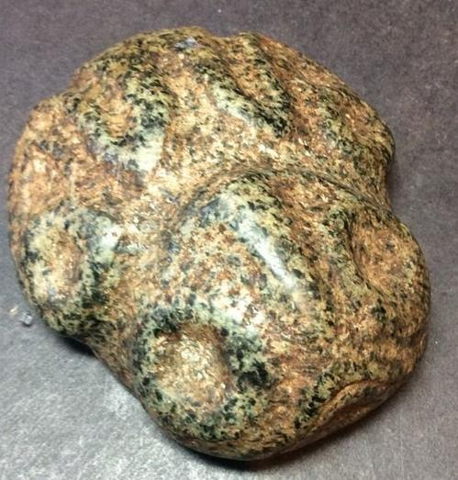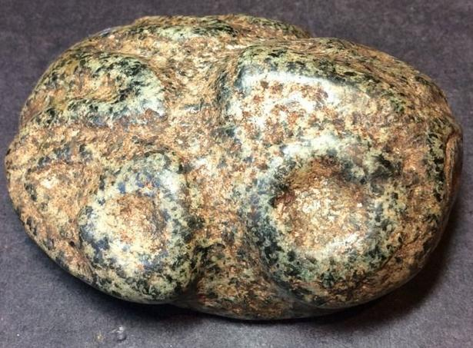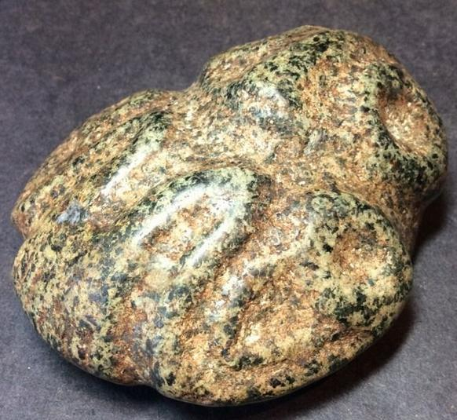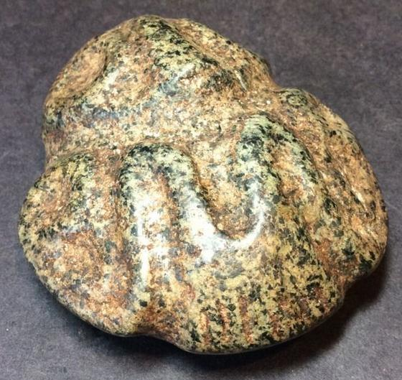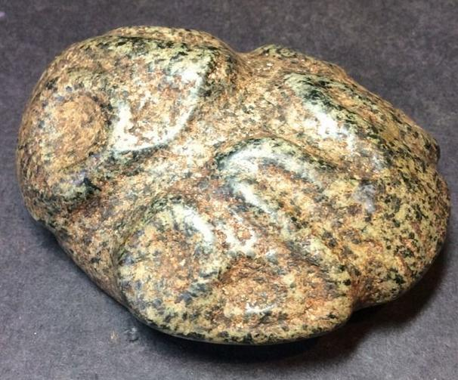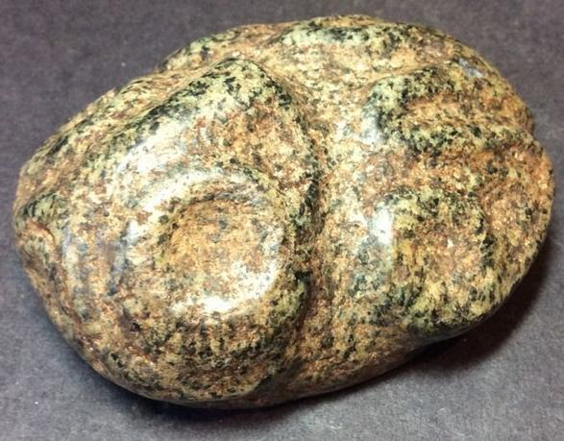

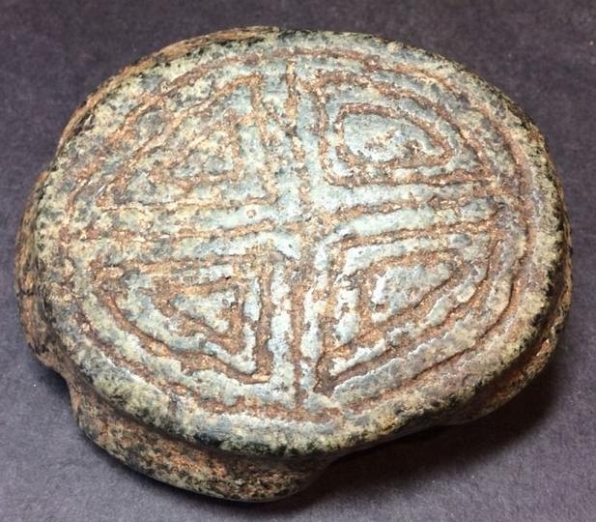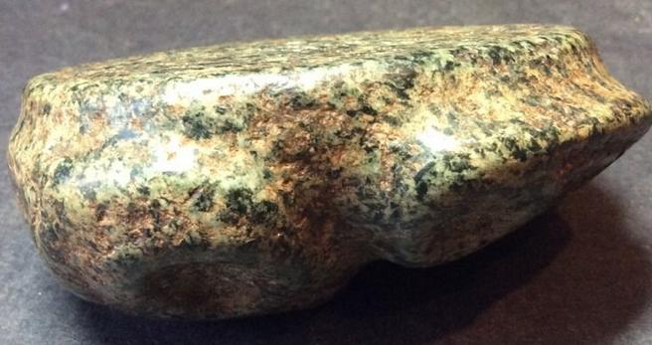

# Order details

## Sales order

Sold by [berkeleylounge](http://myworld.ebay.com/berkeleylounge) ( [1114](http://feedback.ebay.com/ws/eBayISAPI.dll?ViewFeedback&userid=berkeleylounge) )

### Delivery package 1 of 1

Estimated delivery Monday, Feb 1, 2016

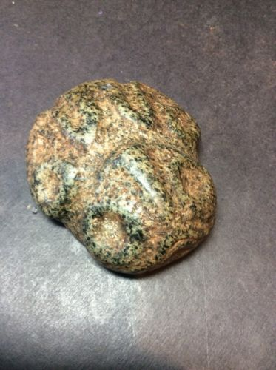

#### [Taino Stone Carving Pre Colombian Frog Stamp Ceremonial Artifact Antique](http://www.ebay.com/itm/172069505580)

|  |  |
| --- | --- |
| Item price | $195.00 |
| Quantity | 1 |
| Item number | 172069505580 |
| Shipping service | Standard Shipping |

## Shipping address

Ralph J Coffman Jr

149 Atlantic Ave

Swampscott MA 01907-2427

United States

## Order total

|  |  |
| --- | --- |
| Subtotal | $195.00 |
| Shipping | $10.00 |

**Total**

$205.00